Ideation Phase Brainstorm& Idea Prioritization Template

|  |  |
| --- | --- |
| Date | 1 November 2022 |
| Team ID | PNT2022TMID18950 |
| Project Name | Project – Real Time River Water Quality  Monitoring System |
| Maximum Marks | 4 Marks |

***Brainstorm & Idea Prioritization:***

**Step-1: Team Gathering, Collaboration and Select the Problem Statement**

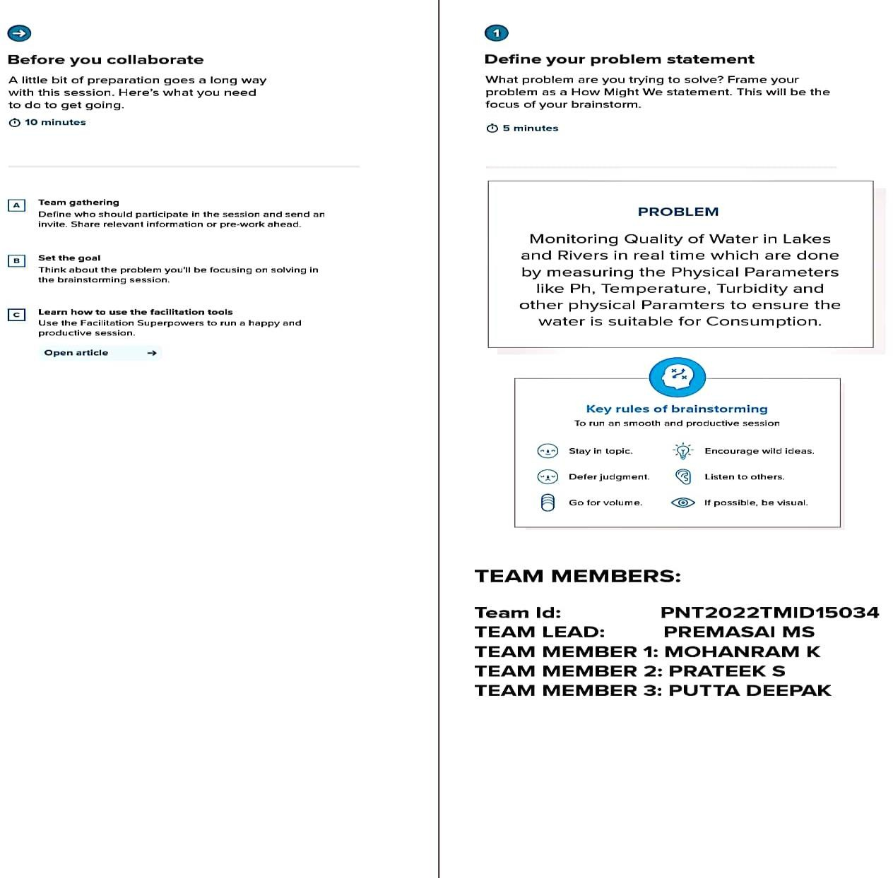

**Team Lead : Kanish Kumar**

**Team member 1 : Dharineeshh**

**Team member 2 : Aakash**

**Team member 3 : Chandraruban**

